**DGen – User Guide**

**ABOUT DGen:**

**DGen –** API based automation utility tool to create new test data / manipulate the test data in T24 Application based on functional testing requirements and that test data can be used respective functional / Regression testing.

**How to Use:**

**Step 1: Set up – Environment Properties**

1. Click on “**Environment Properties**” Tab.
2. Enter T24 Application URL, User Names (CH & US – Normal and Authoriser) in the corresponding **Values** Field.

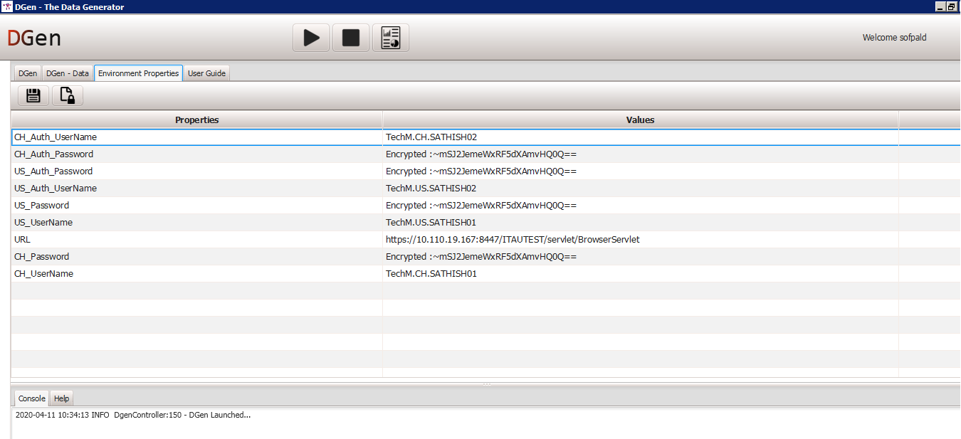

1. Click on  icon to encrypt the User password.
2. Enter User Password in “**Actual Text**” Field

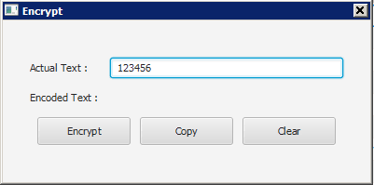

1. Click on “**Encrypt**” button to encrypt the inputted Password.
2. Click on “**Copy**” button to copy the encrypted Password.

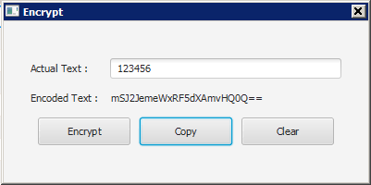

1. Place the Cursor in corresponding Password **Values field** and paste it.
2. Click on  icon to save the inputted Environment Properties

**Step 2: Input Test Data in DGen- Data**

1. Click on “**DGen – Data**” Tab.
2. Below mentioned User Interface components are available under “**DGen – Data**” tab.
   1. **DGen- Data** – Tree Folder Structure to view all Input Data Sheets
   2.  - Adds a new row in Test Data Sheet
   3.  - Adds a New Column in Test Data Sheet
   4.  - Deletes the selected row of the Test Data Sheet
   5.  - Delete the selected column of the Test Data Sheet
   6.  - Saves all changes made in the Test Data Sheet.

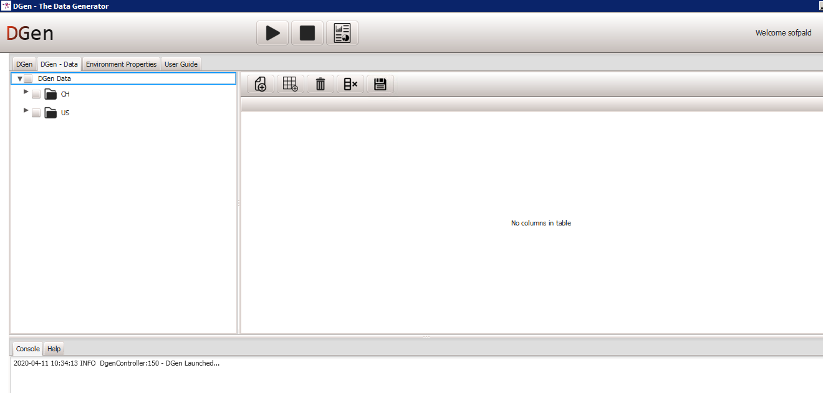

1. Follow the below mentioned flow and perform Test Data Sheet operations
2. Expand the Corresponding folder (CH or US) under “DGen-Data”
3. Lists the test data sheets in tree view format, which are available in **DGen** tool.
4. User can able to expand / collapse the folder and corresponding workbook
5. Double click the selected Worksheet, it will show the Test data sheet values in Right Side Panel.
6. User can add, modify, delete and save test data using corresponding Right Side Panel icons.

***For Example:*** *Refer below mentioned Screenshot for “****CH****” folder –> 01. Container Customer –> Container Customer*

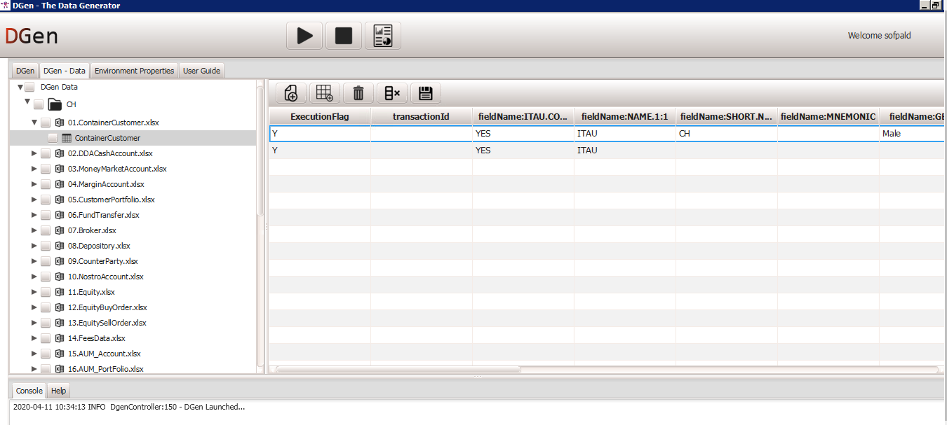

1. Developer support is required to add a new column in the Test Data Sheet. Because those column names are technical names which are retrieved from application through Inspect Element.

**Step 3: Execute the Test Data Script**

1. Click on “**DGen**” Tab.
2. Below mentioned columns are available under “**DGen**” tab.
   1. **Module** : Test Data Script
   2. **Count**: User can enter required test data count.
   3. **CH** : User can select the Check box to create test data for the Region – CH
   4. **US** : User can select the Check box to create test data for the Region – US

***For Example:*** *Refer below mentioned Screenshot for* ***01. Container Customer – Count -2 -> CH & US***

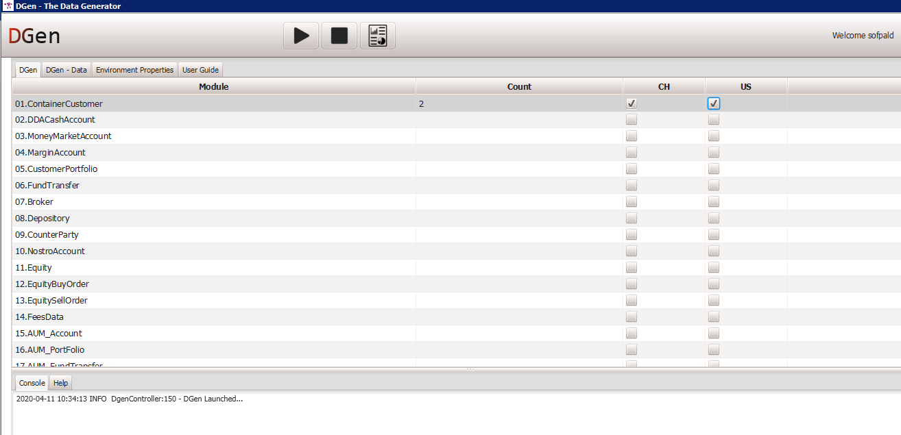

1. Click on  button to execute the test script.
2. User can terminate the execution by using  button.

**Execution Flag:**

For the above Example, user inputted required Test Data Count as “**2”.**

**Case 1: DGen - Data**

**For CH:** Execution flag updated as “Y” for two rows

**For US:** Execution flag updated as “Y” for one row

For this scenario, Test Data script will prepare two test data for each CH and US Region based on following mechanism.

* **CH:** Test Data Script will create first test data based on first row of data and Second test data based on second row of data
* **US:** Test Data Script will create two test data based on first row of data, because the test data sheet does not have second row of data

**Screenshot for CH:**

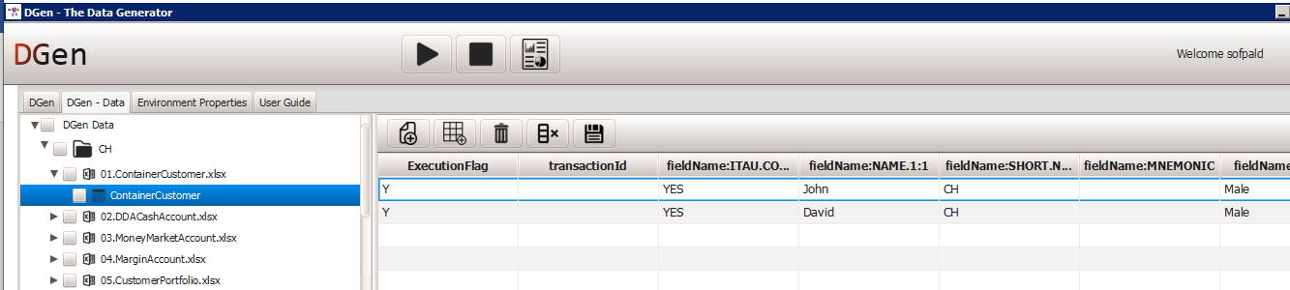

**Screenshot for US:**

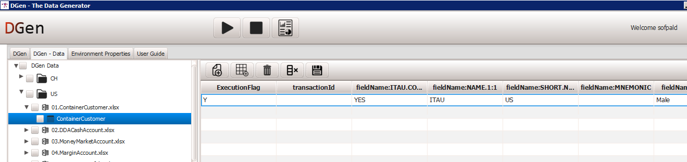

**Case 2: DGen - Data**

**For CH:** Execution flag updated as “Y” for one row and “N” for one row

**For US:** Execution flag updated as “Y” for one row

For this scenario, Test Data script will prepare two test data for each CH and US Region based on following mechanism.

* **CH:** Test Data Script will create two test data based on first row of data, because execution flag updated as “**N**” for second row of data
* **US:** Test Data Script will create two test data based on first row of data, because the test data sheet does not have second row of data

**Screenshot for CH:**

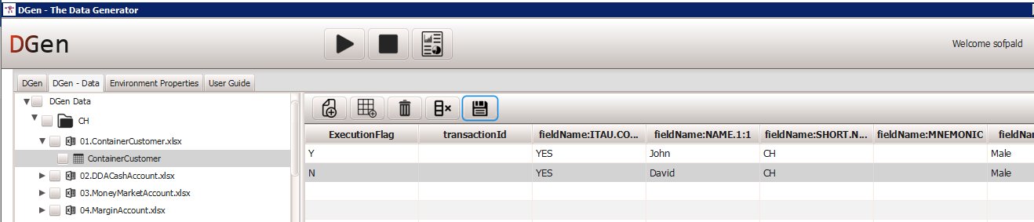

**Screenshot for US:**



**Step 4: Report Log and Output Data**

1. Click “**Ok**” button on “**Completed**” pop up message, which will be displayed after the completion of execution.

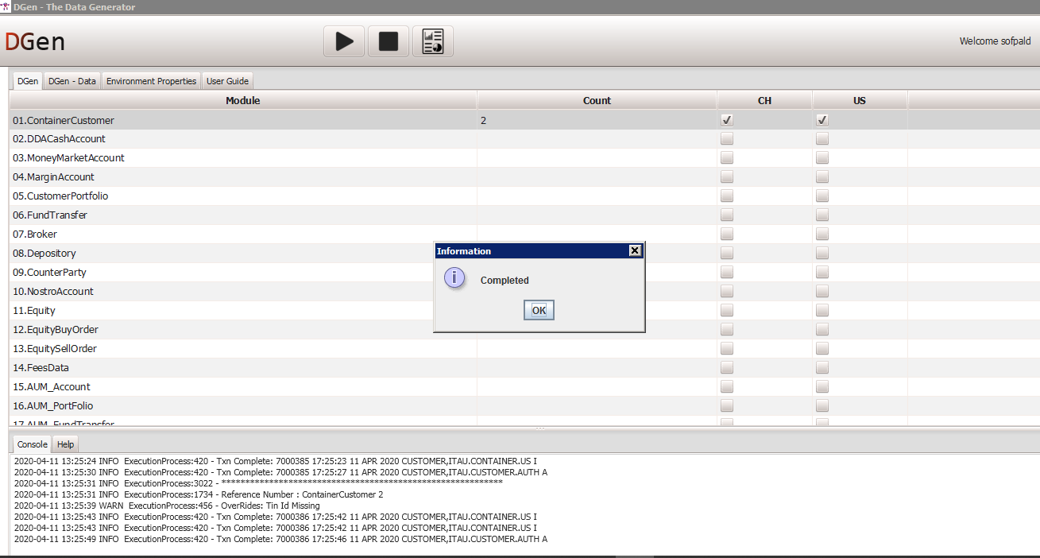

1. Click on  to view the Report log and Output Data.

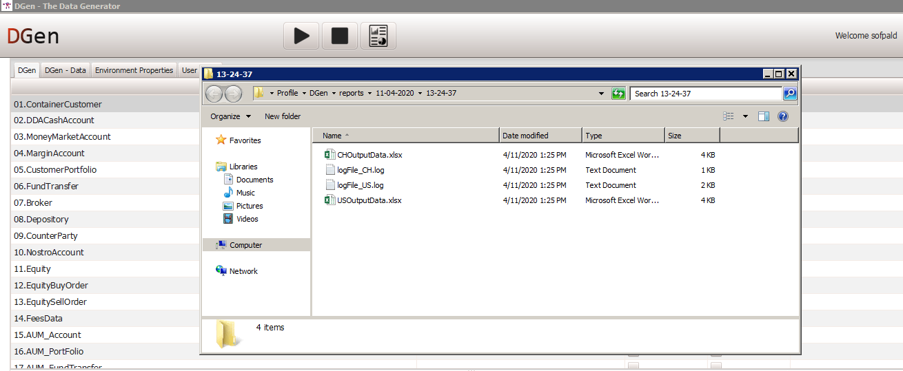

**Sample Output Data:**

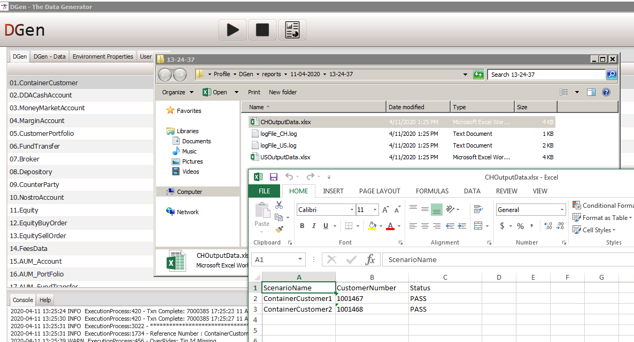

**Sample Report Log:**

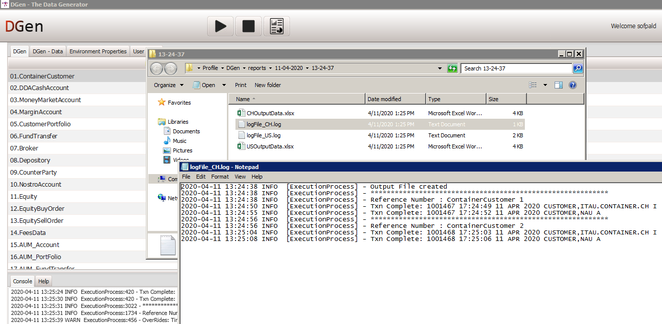

**Console View:**

Displays the execution log content. User can view this log during execution runtime and the same will be updated in Execution Log File (Report Output Folder).

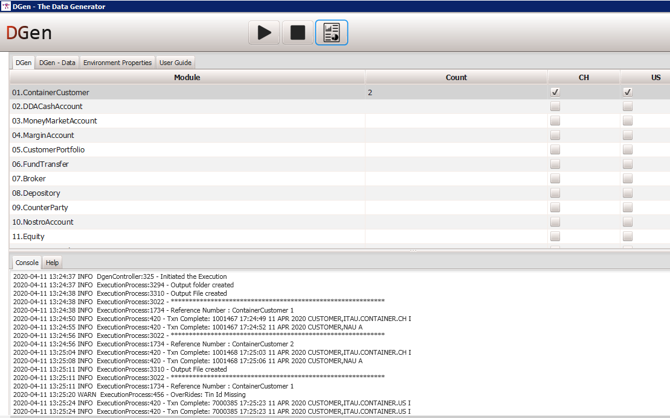

**Help View:**

Displays the below mentioned **Help** content for the selected Test Data Script.

1. Flow Coverage
2. Mandatory Input Test Data Parameters for each corresponding Input Test Data Sheet.